**James Long**

**Student ID: 011476223**

**jlon501@wgu.edu**

**3/11/2024**

**D1: Status of all packages at 9:00 ordered by delivery time.**

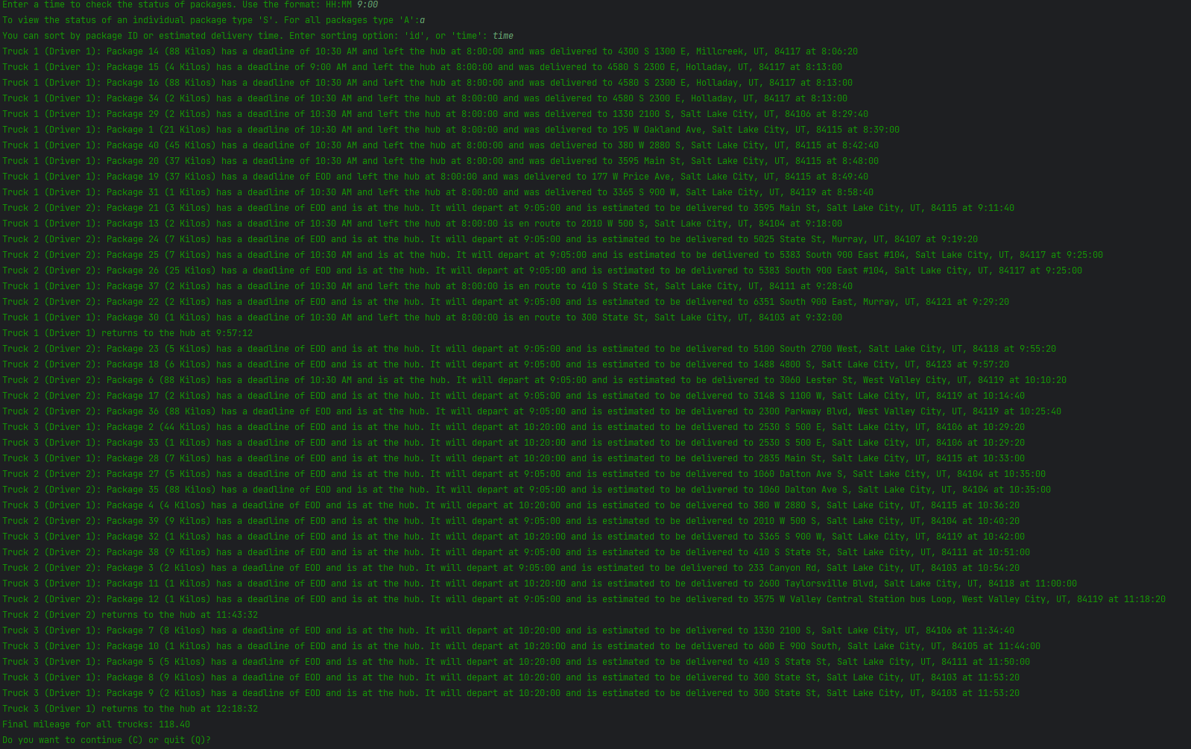

**D2: Status of all packages at 10:00 ordered by delivery time.**

**D3: Status of all packages at 12:30 ordered by delivery time.**

**E: Successful completion of the code including the final mileage for all trucks.**



**F.  Justify the package delivery algorithm used in the solution as written in the original program by doing the following:**

**1.  Describe two or more strengths of the algorithm used in the solution.**

1. The nearest neighbor algorithm is straightforward and easy to understand. It does not require complex formulas, making it simple to apply.

2. The algorithm is efficient as it only requires calculating distances between data points, which means it doesn’t need to consider all possible combinations.

**2.  Verify that the algorithm used in the solution meets all requirements in the scenario.**

The nearest neighbor algorithm gets all 40 packages delivered on time. The total distance traveled is under the required 140 combined miles. All package-specific requirements have been fulfilled.

**3.  Identify two other named algorithms that are different from the algorithm implemented in the solution and would meet all requirements in the scenario.**

**1.** A Genetic Algorithm could be used to deliver packages efficiently in the program. Each route would represent a potential solution, and the algorithm would iteratively refine each route to minimize the total distance traveled while meeting all the delivery requirements. (Kanade, 2023)

**2.** An Ant Colony algorithm could be applied to find optimal delivery routes for the trucks. It involves simulating the behavior of ants as they search for food, laying pheromone trails to communicate to each other which paths are shortest. This can be applied to the delivery program where each ant would represent individual routes, and they would deposit pheromones on the paths they traverse based on the quality of the route. Efficient routes would be established to guide the search and meet delivery deadlines and package requirements. (Dorigo, 2007)

**a.  Describe how both algorithms identified in part F3 are different from the algorithm used in the solution.**

Nearest neighbor picks the nearest option without thinking ahead. It chooses the closest neighbor at each step until all packages have been delivered. The Genetic Algorithm mixes and matches paths to create more efficient paths over generations. The Ant Colony algorithm uses artificial ants to leave trails for other ants to follow. The more ants follow a trail, the stronger the trail becomes, leading more ants to use it until they find the best possible path.

**G.  Describe what you would do differently, other than the two algorithms identified in part F3, if you did this project again, including details of the modifications that would be made.**

If I were to do this project again or continue to work on it, I would design the routing program to be scalable and adapt to different cities with varying characteristics and constraints. Implementing real-time changes and factors like traffic conditions, road closures or package priority would also be a concern in a real-world environment. Route planning would need to optimize routes instead of just finding the shortest mileage possible. I would create a more user-friendly interface for route-planning and monitoring.

**H.  Verify that the data structure used in the solution meets all requirements in the scenario.**

The hash table stores and retrieves package information accurately, ensuring that all packages are with associated data. The hash table is scalable with a larger number of packages. The load factor implemented serves as a parameter to balance memory usage and performance.

1. **Identify two other data structures that could meet the same requirements in the scenario.**

**1.** A priority queue data structure could store the packages and efficiently select the next package for delivery based on a certain criteria, such as delivery time or delivery location. Packages would be inserted into the priority queue with their priorities determined by these criteria.

**2.** A binary heap is a tree-based data structure that satisfies the heap property, which can either be a min-heap or a max-heap. Binary heaps are well-suited for priority queue implementations, where elements with higher priority are processed before elements with lower priority.

**a.  Describe how each data structure identified in H1 is different from the data structure used in the solution.**

Unlike a hash table, a priority queue focuses on the order of which the elements should be processed based on their priority. A binary heap differs from a hash table in that it does not support efficient lookup or deletion of elements not at the root. Maintaining the heap property during insertion and deletion can often times require complex restructuring of the heap.

**I.  Acknowledge sources, using in-text citations and references, for content that is quoted, paraphrased, or summarized.**

Dorigo, M. (2007). *Ant colony optimization*. Scholarpedia.

Retrieved March 11, 2024 from

<http://www.scholarpedia.org/article/Ant_colony_optimization>

Kanade, V. (2023, September 6). *Genetic algorithms - meaning, working, and applications*. Spiceworks.

Retrieved March 11, 2024 from

https://www.spiceworks.com/tech/artificial-intelligence/articles/what-are-genetic-algorithms/

**J.  Demonstrate professional communication in the content and presentation of your submission.**